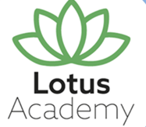


Careers Education Policy

Date Published | July 2025
Version | 2
Approved Date | May 2026
Review Cycle | Annual
Review Date | May 2027

An academy within:
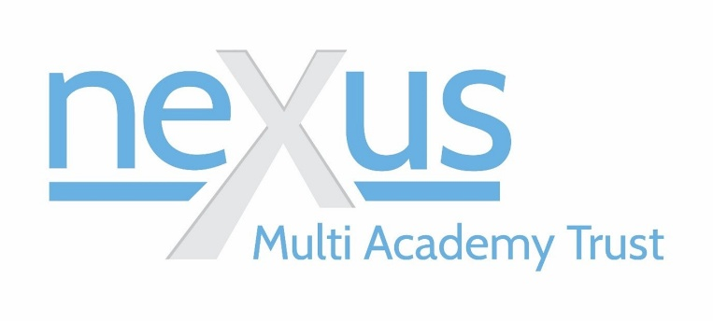

“Learning together, to be the best we can be”

- Policy Statement

  - At Lotus Academy we are committed to providing all students with comprehensive, impartial, and high-quality careers education and guidance.

  - In line with the updated statutory guidance issued on May 8, 2025, we aim to equip students with the knowledge and skills necessary to make informed decisions about their future pathways, including further education, apprenticeships, and employment.

  - We are committed to meeting statutory responsibilities relating to careers education and guidance under the Education Act 2011, the Technical and Further Education Act 2017 and the Provider Access Legislation. In implementing these duties the school follows the Department for Education statutory guidance 'Careers guidance and access for education and training providers (January 2023)' and aligns its careers programme with the Gatsby Benchmarks of Good Career Guidance.

  - Careers provision contributes to expectations outlined in the Ofsted Education Inspection Framework and Labour Market Information (LMI) to align with Gatsby Benchmark 2.

- Objectives

  - Impartial Guidance: We will ensure all students receive unbiased information about a range of career options, including academic routes, apprenticeships, and vocational pathways. This is through access to our qualified Nexus Careers Advisor, Jenny Hallam and our Sheffield City Council IAG Advisor, Qamar Nawaz.

  - Personalised Support: Provide tailored advice that considers individual aspirations, strengths, and circumstances.

  - Employer Engagement: Develop strong partnerships with local businesses and industries to offer students real-world insights and opportunities.

  - Digital Integration: Utilise AI-driven tools to enhance career exploration, CV writing, and interview preparation, ensuring equitable access to resources.

  - Continuous Development: Regularly review and update the careers program to align with evolving labour market trends and student needs.

- Implementation

  - We will integrate careers education into the curriculum from KS2, with both dedicated and embedded sessions across the curriculum.

  - At Lotus Academy we will work towards providing all students with at least 2 weeks of meaningful workplace experiences by the end of Year 11, facilitating exposure to various industries.

  - We organise a combinations of career fairs, workshops, information sessions and employer-led sessions to broaden students' understanding of potential career paths.

  - The school offers personalised sessions focusing on post-16 options.

  - The school will engage parents through information sessions and resources to support students' career decision-making processes.

  - Opportunities are offered for students to find out about technical education qualifications and apprenticeships opportunities.

- Accountability and Quality
  - Quality assurance and continuous improvement is a key part of our career’s programmes. This forms part of our careers programme planning and includes regular evaluation, alongside reviewing progression data.

  - We understand Ofsted MUST comment on CEIAG and has an obligation to highlight where our provision may be lacking.

  - We understand the role of destination data in tracking quality and the requirement to maintain good contact with LA who compile performance tables.

  - We will use Compass+ to support the above aspects.

The Role of SLT, the Trust Board of Directors and Nexus Central Trust Team
  - The DfE expects SLT, the Board of Directors to:

- support their careers team, especially their careers leader
- invest in personal guidance provided by a qualified careers adviser

4.6. We understand that it is good practice for a Governor role to oversee the delivery of careers and ensure that it meets the statutory requirements. This role should also hold the SLT to account for delivery. At Nexus MAT, the Board of Directors holds this responsibility.

4.7.The Trust Central Team will provide clear advice and guidance to the Career’s leader/SLT on which they can base a strategic careers plan which meets the legal or contractual requirements. The plan should:

- be developed in line with the Gatsby Benchmarks
- be informed by the requirements and expectations set out in this document
- show how the careers programme will be implemented
- show how its impact will be measured

- Independent Careers Guidance

Purpose
  - At Lotus Academy we are committed to ensuring that all students receive high-quality, impartial careers guidance that supports their individual goals and prepares them effectively for adulthood.

Entitlement

  - Legal Requirements: The Careers guidance, issued under Section 45A of the Education Act 1997, mandates that as an academy we must provide independent careers guidance to students in years 7 to 13.

  - This guidance must include appropriate information in line with the student’s pathway and aspirations.

  - Independent and impartial careers guidance from a trained and accredited adviser will be provided.

  - Guidance tailored to individual aspirations and abilities, taking into account any additional learning or support needs will be provided.

  - Every student will have at least one personal guidance *meeting with our Careers Adviser by the age of 16. Meetings should be scheduled in the careers programme to meet the needs of student.
*Meetings will be bespoke and designed in line with the needs of the student

Delivery
  - Careers guidance is delivered through:

- 1:1 sessions with a Nexus, qualified independent careers adviser and/or a Sheffield City Council IAG advisor, at key transition points (Year 9 EHCP reviews and post-16).
- EHCP Annual Reviews which include a focus on preparation for adulthood through areas of employment, independent living, and participation in the community.
- Work-related learning opportunities, including supported internships, vocational tasters, and community-based placements, as appropriate.
- Collaboration with parents/carers to ensure shared understanding and support for students' career aspirations.

Accessibility and Inclusion

  - We will ensure that careers advice is:

- Accessible in format and communication, using appropriate methods such as symbols, simplified language, or assistive technology.
- Culturally sensitive and inclusive of the diverse backgrounds of our students.
- Delivered in a safe and supportive environment, respecting each student's pace and preferred way of working.

Monitoring and Evaluation
  - The school monitors the quality and impact of careers guidance by:

- Gathering feedback from students, families, and advisers.
- Tracking student destinations after leaving school to assess the effectiveness of the guidance. (Data to be held on Compass +)

- Provider Access Legislation & PAL Statement

  - In line with the updated Provider Access Legislation (January 2023), we are committed to providing meaningful access for all pupils in Years 8 to 13 to approved providers.

  - We have set out a policy statement outlining the circumstances in which education and training providers will be given access to our students. The policy statement includes:

- any procedural requirements about requests for access
- grounds for granting or refusing requests
- details of premises or facilities available to a person who is given access
- the times access can be given
- how we will meet the legal requirement to put on 6 provider encounters
- Our careers leader will review the policy statement annually and agree it with the Head/Governors.

  - We will meet the new legal requirement to put on at least four encounters with providers/approved organisations by providing:

  - 2 encounters that are mandatory for all students across years 8/9
  - 2 encounters that are mandatory for all students across years 10/11

  - Please see link to the full PAL document on our website: Lotus Academy - Careers

- Monitoring and Evaluation

  - Feedback Mechanisms: We will collect regular feedback from students, parents, and employers to assess the effectiveness of the careers program.

  - Progress Tracking: We will monitor student outcomes post-graduation to evaluate the impact of careers education on their career trajectories.

  - Continuous Improvement: We will use evaluation data to make informed adjustments to the careers program, ensuring it remains responsive to student needs and labour market developments.

  - Resources: Compass+ will be used to benchmark, manage, track and report on our careers provision. We will use this tool to evaluate our careers activity against the 8 Gatsby Benchmarks. Compass+ integrates with our management information systems to support more targeted careers programme planning and delivery.

- Compliance and Relevant Legislation

  - This policy is in line with statutory guidance from the Department for Education (DfE) issued under Section 45A of the Education Act 1997.

  - This policy complies with the updated statutory guidance for careers education and guidance issued on May 8, 2025, and aligns with the Gatsby Benchmarks for Good Career Guidance.

  - The school will appoint a Careers Leader responsible for leading and coordinating the careers programme. The Careers Leader will normally hold, or be working towards, a Level 6 Careers Guidance qualification.

For further information or to discuss specific aspects of this policy, please contact Adele Hetherington at ahetherington@nexusmat.org, 0114 2456305.

The school will publish a Provider Access Policy Statement outlining how providers can request access to students.

Appendix
Providers who have been invited into Lotus Academy or have provided on site workplace experience/visits to date include (Below provided as an example):
ASK Apprenticeships
Sheffield College
Rotherham College
Sheffield Utd Community College
Job Centre plus
Careers enterprise
Amey
NG Bailey
Mattress warehouse online
Botanical Gardens
Pizza Express
Big Challenge
Doka construction
National gaming museum
FORTEM

