

Anti-Bullying Policy

Date Published | September 2025
Version | 1
Approved Date | October 2025
Review Cycle | Annual
Review Date | October 2026

An academy within:


“Learning together; to be the best we can be”

- Statement of Intent

  - At Lotus Academy we are committed to providing a warm, caring and safe environment for all our children so that they can learn and play in a relaxed and secure environment. Bullying of any kind is unacceptable and will not be tolerated in our school. We take all incidents of bullying seriously. Bullying hurts. No-one deserves to be a victim of bullying. Everybody has the right to be treated with respect and children who are bullying others need to learn different ways of behaving.

  - Bullying happening from time to time at all schools. At Lotus Academy, if bullying does occur, everyone should be able to tell and know that incidents will be dealt with promptly and effectively in accordance with our anti-bullying policy. We are a TELLING school. This means that anyone who knows that bullying is happening is expected to tell the staff.

  - At Lotus Academy, we have a duty of care to both bully and victim. While the priority is to preserve the safety of the victim, we seek to understand the bully so that we can put appropriate support in place. We will thoroughly investigate the possibility of safeguarding, mental health or general wellbeing issues with the bully. Our non-punitive approach aims to teach the bully the impact of their actions and make a lasting change to their behaviour.

- Aims and Objectives of this Policy

  - The aim of this policy is to try and prevent and deal with any behaviour deemed as bullying. The implementation of this policy will create an ethos where bullying is regarded as unacceptable so that a safe and secure environment is created for everyone to learn and work in.

  - All members of the school have a responsibility to recognise bullying when it occurs and take appropriate action in accordance with the school policy. This will happen in the following ways:

- The school will meet the legal requirement for all schools to have an anti-bullying policy in place.
- The school will work closely with other professional agencies to ensure that children stay safe as stated in The Children Act 1989, The SEN and Disability Act 2001, The Government Green Paper ‘Every Child Matters’ 2003 (outcome 2) and The Children Act 2004.
- All governors, teaching and non-teaching staff, children and parents/guardians will have an understanding of what bullying is.
- All governors, teaching and non-teaching staff will know what the school policy is on bullying and will consistently and swiftly follow it when bullying is reported.
- All children and parents/guardians will know what the school policy is on bullying and what they can do if bullying occurs.
- Children and parents/guardians will be assured that they will be supported when bullying is reported.
- Whole school initiatives (staff training, celebration assemblies etc) and proactive teaching strategies (PHSE [Personal, Health & Social Education] lessons, circle time etc) will be used throughout the school to reduce the opportunities for bullying to occur.
- A positive, caring ethos will be created within the school environment where everyone can work, play and express themselves, free from the fear of being bullied.

- What is Bullying?

  - The school has adopted the following collaborative definition of bullying which is our shared understanding of what bullying is

  - Bullying is any deliberate, hurtful, upsetting, frightening or threatening behaviour by an individual or a group towards other people. It is repeated over a period of time and it is very difficult for the victims to defend themselves. Bullying results in worry, fear, pain and distress to the victims.

Bullying can be:
- Emotional being unfriendly, excluding, tormenting (e.g. hiding books, threatening gestures), ridicule, humiliation
- Verbal name-calling, sarcasm, spreading rumours, threats, teasing, making rude remarks, making fun of someone
- Physical pushing, kicking, hitting, pinching, throwing stones, biting, spitting, punching or any other forms of violence, taking or hiding someone’s things
- Racist racial taunts, graffiti, gestures, making fun of culture and religion
- Sexual unwanted physical contact or sexually abusive or sexist comments
- Homophobic because of/or focussing on the issue of sexuality
- Online/cyber setting up ‘hate websites’, sending offensive text messages, emails and abusing the victims via their mobile phones
- Any unfavourable or negative comments, gestures or actions made to someone relating to their disability or special educational needs.

Bullying is not:
  - It is important to understand that bullying is not the odd occasion of falling out with friends, name calling, arguments or when the occasional trick or joke is played on someone.
  - It is bullying if it is done several times on purpose (STOP). Children sometimes fall out or say things because they are upset. When occasional problems of this kind arise it is not classed as bullying. It is an important part of children’s development to learn how to deal with friendship breakdowns, the odd name calling or childish prank. We all have to learn how to deal with these situations and develop social skills to repair relationships.
Where does bullying happen?
  - It can happen anywhere – in the classroom, in the corridor, in the toilets, in the dining hall, in the playground. Bullying may also happen on the way to and from school. In such cases, the Head teacher is empowered by law to deal with such incidents but must do so in accordance with the school’s policy.
  - At Lotus Academy, we are concerned with our children’s conduct and welfare outside as well as inside school and we will do what we can to address any bullying issues that occur off the school premises. The following steps may be taken:
- Talk to the local Community Police Officer about problems on the streets
- Talk to the transport companies about bullying on school buses and in school taxis
- Talk to the Head Teachers of other schools whose children may be involved in bullying off the premises
- Discuss coping strategies with parents
- Talk to the children about how to handle or avoid bullying outside the school premises

- Signs and Symptoms
4.1. A child may indicate, by different signs or behaviour, that he or she is being bullied.
4.2. Adults should be aware of these possible signs and investigate further if a child:
- Is frightened of walking to or from school
- Doesn’t want to go on the school/in the taxi
- Begs to be driven to school
- Changes their usual routine/route to school
- Begins truanting
- Becomes withdrawn, anxious or lacking in confidence
- Starts stammering
- Attempts or threatens suicide or runs away
- Cries themselves to sleep at night or has nightmares
- Feels ill in the morning
- Begins to underperform in school work
- Comes home with clothes torn or books damaged
- Has possessions go “missing”
- Asks for money or starts stealing money (to pay the bully)
- Has dinner or other monies continually “lost”
- Has unexplained cuts or bruises
- Comes home starving (money/snack/sandwiches have been stolen)
- Becomes aggressive, disruptive or unreasonable
- Starts swearing or using aggressive language for no apparent reason
- Is bullying other children or siblings
- Stops eating
- Is frightened to say what’s wrong
- Gives improbable excuses for any of the above

4.3. These signs and behaviours could indicate other problems, but bullying should be considered a possibility and should be taken seriously and investigated as soon as possible.

- Supporting the Victim
What Can You Do if You Are Being Bullied?
5.1. Staff will educate and raise awareness on What Can You Do if You Are Being Bullied? Overarching messages include:
- Wherever you are in school, you have the right to feel safe.
- Nobody has the right to make you feel unhappy.
- If someone is bullying you, it is important to remember that it is not your fault and there are people who can help you.
- Try not to let the bully know that he/she is making you feel upset.
- Try to ignore them.
- Be assertive – stand up to them, look at them directly in the eye, tell them to stop and mean it.
- Stay in a group, bullies usually pick on individuals.
- Get away as quickly as you can.
- Tell someone you can trust – it can be an adult in school, e.g. a teacher, a teaching assistant, the wellbeing team, a parent or carer, a friend, a brother, a sister or a relative.
- If you are scared, ask a friend to go with you when you tell someone.
- If you don’t feel you can talk to someone about it, write it down and post it in the school listen up box.
- When you tell an adult about the bullying give them as many facts as you can (What? Who? Where? When? Why? How?).
- Keep a diary of what’s been happening and refer to it when you tell someone.
- Keep on speaking out until someone listens and helps you.
- Never be afraid to do something about it and quick.
- Don’t suffer in silence.
- Don’t blame yourself for what is happening.
- Call a helpline.

Procedures in school for reporting bullying
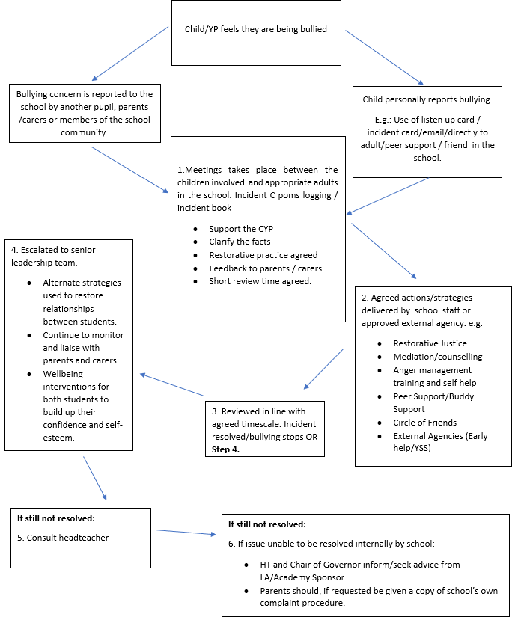

- The Role of The Bystander

  - Staff will educate children and raise awareness of the role of the bystander. Overarching messages to children include:
- Ignoring bullying is cowardly and unfair to the victim.
- Staying silent means the bully has won and gives them more power.
- There are ways you can help without putting yourself in danger.
- Don’t smile or laugh at the situation.
- Don’t rush over and take the bully on yourself.
- Don’t be made to join in.
- If safe to do so, encourage the bully to stop bullying.
- If you can, let the bully know you do not like their behaviour.
- Shout for help.
- Let the victim(s) know that you are going to get help.
- Tell a member of staff as soon as you can.
- Try and befriend the person being bullied.
- Encourage the person to talk to someone and get help.
- Ask someone you trust about what to do.
- Call a helpline for some advice.

7. Generative artificial intelligence (AI)
  - Artificial intelligence (AI) tools are now widespread and easy to access. Staff, pupils and parents/carers may be familiar with generative chatbots such as ChatGPT and Google Bard.

  - Lotus Academy recognises that AI has many uses to help pupils learn, but may also have the potential to be used to bully others. For example, in the form of 'deepfakes', where AI is used to create images, audio or video hoaxes that look real.

  - Lotus Academy will treat any use of AI to bully pupils in line with our Anti-Bullying, Behaviour and Safeguarding policies.

- Bullying of Children with Special Educational Needs

  - Lotus Academy is an inclusive school. We provide a secure, accepting, safe and stimulating environment where everyone is valued for who they are.

  - We have some children who have learning disabilities and/or communication difficulties. Everyone involved in the school is very aware that these children can be especially vulnerable to bullying and we are therefore particularly vigilant at all times.

  - Higher attainers, gifted or talented children can also be affected by bullying. Staff will treat this type of bullying seriously and in the same way as any other type of bullying.

- Procedures for Reporting and Responding to Bullying Incidents

  - All staff will respond calmly and consistently to all allegations and possible incidents of bullying at Lotus Academy. They will be taken seriously by all staff and dealt with impartially and promptly. All those involved will have the opportunity to be heard. Staff will protect and support all children involved whilst allegations and incidents are investigated and resolved.

  - All staff will use the following procedure for reporting and responding to bullying allegations or incidents:

- Respond calmly and consistently
- Take all reports seriously
- Protect and support all involved
- Use a restorative approach
- Bullying incidents will be discussed regularly at pupil review

Step-by-step process:
Report: All bullying incidents must be reported to staff and logged on CPOMS.
Listen: Staff will speak to all parties separately and ensure the victim feels safe.
Respond: Staff will identify the problem and suggest solutions.
Restore: Pupils may be offered restorative conversations.
Monitor: Cases will be monitored to prevent recurrence.
Escalate: Serious cases will be referred to SLT, safeguarding team, or external agencies.

  - Follow-up measures include:
- Parents will be informed and will be invited to come into school for a meeting to discuss the problem.
- After the incident has been investigated and dealt with, each case will be monitored to ensure repeated bullying does not take place.
- If necessary and appropriate, the Safeguarding Lead in school, Social Care or police will be consulted.

- Response to Bullying
  - At Lotus Academy, we will respond to bullying with appropriate measures, including:
- Restorative conversations and conflict resolution between both parties.
- Verbal or written apologies
- Use break times to review what is or has been happening
- Removal from class to be educated away from other children
- Discussion of response from Senior Leadership Team
- Fixed term or permanent exclusion

- Strategies for the Prevention and Reduction of Bullying

  - Whole school initiatives and proactive teaching strategies will be used throughout the school to develop a positive learning environment with the aim of reducing the opportunities for bullying to occur.

  - These can include:
- Using a restorative approach to help students understand the impact their actions have on others.
- Involving the whole school community in writing and reviewing the policy
- Undertaking regular questionnaires and surveys to monitor the extent of bullying in the school and the effectiveness of the Anti-Bullying Policy
- Producing a ‘child speak’ version of the policy for the children
- Each class agreeing on their own set of class rules
- Making national anti-bullying week a high-profile event each year
- Awareness raising through regular anti-bullying assemblies
- PHSE (Personal, Health & Social Education) scheme of work from year 1 to year 14 used to support this policy
- Circle time on bullying issues
- Setting up of a circle of friends support network where a small group of children volunteer to help and support an individual experiencing difficulties
- Children writing stories and poems and drawing pictures about bullying
- Children being read stories about bullying
- Using drama activities and role-plays to help children be more assertive and teach them strategies to help them deal with bullying situations
- Creation of an anti-bullying school notice board in the school library
- Prominently displaying anti-bullying posters produced by the children around the school
- Introducing playground improvements and initiatives
- Using praise and rewards to reinforce good behaviour
- Encouraging the whole school community to model appropriate behaviour towards one another
- Organising regular anti-bullying training for all staff

- Monitoring and Evaluation of the Policy
  - To ensure this policy is effective, it will be regularly monitored and evaluated. Questionnaires completed by the whole school community, together with surveys, focus groups, children’s and parents’/guardians’ feedback, bullying incident logs will be used to gauge the effectiveness of the policy.

  - Following an annual review any amendments will be made to the policy and everyone informed. An annual report will then be issued to governors and parents and the policy will be distributed to all parents.

12. Sources of Further Information, Support and Help
  - There is a vast amount of information and guidance available about bullying that can provide a wide range of support and help. The following list is just a small selection of the support available that teachers, parents and children have found useful.
Name of organisation Telephone number | Website
Act Against Bullying 0845 230 2560 | www.actagainstbullying.com
Advisory Centre for  0207 704 3370  Education (ACE) | www.ace-ed.org.uk
Anti-bully not available | www.antibully.org.uk
Anti-Bullying Alliance (ABA) 0207 843 1901 | www.anti-bullyingalliance.org.uk
Anti-bullying Network 0131 651 6103 | www.antibullying.net
Beatbullying 0845 338 5060 | www.beatbullying.org.uk
Bully Free Zone 01204 454 958 | www.bullyfreezone.co.uk
Bullying Online 020 7378 1446 | www.bullying.co.uk
BBC not available | www.bbc.co.uk
0800 1111 (helpline for  Childline children) | www.childline.org.uk
020 7730 3300 (general  Kidscape enquiry number)  08451 205 204 (helpline | www.kidscape.org.uk www.beyondbullying.com
for adults only)
NSPCC 0207 825 2500 | www.nspcc.org.uk
Parentline Plus 0808 800 2222 | www.parentlineplus.org.uk
The Children’s Legal  0800 783 2187  Centre | www.childrenslegalcentre.com
The Office of the Children’s  0844 800 9113  Commissioner | www.childrenscommissioner.org.uk
UK Government Website not available | www.direct.gov.uk

