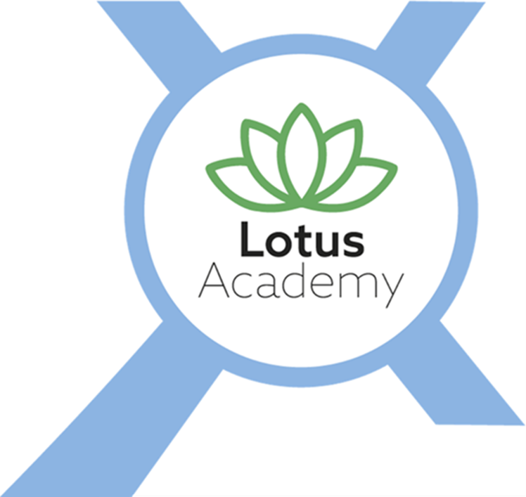

Relationships and Sex Education (RSE) and Health Education Policy

Date Published | September 2024
Version | 3
Approval Date | May 2026
Review Cycle | Annual
Review Date | May 2027

An academy within:
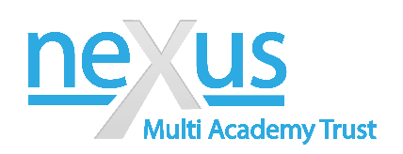

"Learning together; to be the best we can be"

- Introduction

  - Our school’s policy on Relationships and Sex Education (RSE) and Health Education is based on the requirements of the Education Act 2002 and the statutory guidance issued by the Department for Education (DfE). Relationships Education (primary), Relationships and Sex Education (secondary) and Health Education are compulsory subjects.
  - This policy reflects the July 2025 statutory RSHE guidance, which strengthens expectations around safeguarding, online safety, sexual harassment and abuse, equality, inclusion, and support for vulnerable pupils.
  - RSE and Health Education are central to our safeguarding culture. Teaching is designed to equip pupils with the knowledge, skills and confidence to recognise unsafe situations, seek help, and build respectful, healthy relationships both on and offline.
  - The purpose of this policy is to set out the ways in which our school’s provision for relationships and sex education will support pupils through their spiritual, moral, social, emotional and physical development, and prepare them for the opportunities, responsibilities and experiences of life. Our PSHE curriculum aims to enable our pupils to put their knowledge into practice by developing resilience, knowing how and when to ask for help and where to access support. The guidance also sets out both the rights of parents / carers to withdraw pupils from sex education (but not Relationships or Health Education) and the process that headteachers should follow in considering a request from a parent. Parents have the right to request that their child be withdrawn from some or all of sex education, delivered as part of statutory RSE and Health Education (2023)
  - As the guidance states, schools are able to determine how to deliver the content set out in the DfE guidance, in the context of a broad and balanced curriculum. Staff are fully aware that the delivery of RSE and Health Education lessons for some of our children may trigger experiences of past childhood trauma. This alone or in addition to a lower developmental age and understanding mean that when teaching RSE and Health Education; close partnerships with the school’s wellbeing team, parents, carer’s, social workers and virtual schools may be called upon to support the RSE and Health Education work with the child/ young adult.
- Aims and objectives

2.1. We teach children to:
  - use correct scientific anatomical terminology;
  - understand physical and emotional changes during puberty;
  - develop body confidence and positive self-concept;
  - understand human reproduction in an age-appropriate and factual way;
  - recognise and build healthy, respectful relationships;
  - understand consent, boundaries and the right to say no;

  - challenge stereotypes, discrimination and misogyny;
  - recognise and respond to harmful behaviours, including sexual harassment and abuse;
  - manage online relationships and digital risks;
  - understand protected characteristics under the Equality Act 2010;
  - know how and where to seek help and support.

2.2. Teaching explicitly addresses the prevention of sexual harassment, harmful sexual behaviour, coercion and exploitation, in line with DfE expectations on safeguarding and violence against women and girls.

Context

  - High quality sex and relationships education helps create safe school communities in which pupils can grow, learn and develop positive, healthy behaviour for life. We teach RSE and Health Education on the understanding that:
  - it is taught in the context of family life;
  - it is part of a wider process of social, personal, spiritual and moral education;
  - children should be taught to have respect for their own bodies;
  - children should learn about their responsibilities to others, and be aware of the consequences of sexual activity;
  - our young people have the right to say no and they are able to change their minds at any point during sexual activity
  - our young people are aware of the rights of others and are taught about the importance of consent
  - children develop respect for diversity, risk management and support seeking skills.
  - it is important to build positive relationships with others, involving trust and respect, both in person and online;
  - it makes a significant contribution to our duty to safeguard and protect all children;
  - it plays a key role in improving health outcomes for children and young people, enhancing their decision making and support seeking skills and reducing teenage pregnancy and risk-taking behaviour

  - Our RSE and Health Education programme is one of the most important ways we act on our responsibility to safeguard and protect our children, as set out in our Safeguarding/Child Protection policy. We also refer to guidance from the government and expert organisations on specific safeguarding issues, which are relevant to our cohort of children, as
listed in Keeping Children Safe in Education. To safeguard children effectively it is vital that opportunities are created in the curriculum to teach about healthy behaviour, caring relationships, online safety and when and how to get help. At our school we encourage children to develop skills in these areas so that they are equipped with strategies to

help themselves in preventing or reporting harm or abuse. Lessons are planned with clear safeguarding outcomes. Staff are trained to recognise disclosures and follow the school’s safeguarding procedures immediately. RSE content is trauma-informed and sensitive to pupils’ lived experiences, including those who are care-experienced or have SEND.

Equality, Inclusion and SEND.

  - We deliver RSE in accordance with the Equality Act 2010 and the Public Sector Equality Duty. All pupils are entitled to access RSE regardless of background, belief, gender, disability or sexual orientation.
  - RSE teaching reflects the diversity of families, relationships and experiences while remaining factual, age-appropriate and respectful. Reasonable adjustments are made to ensure pupils with SEND can access the curriculum meaningfully, without lowering safeguarding expectations.

Online safety and Digital Relationships

  - RSE and Health Education explicitly address online harms, including:
- pornography and its impact on relationships and expectations;
- online misogyny, harassment and exploitation;
- image-based abuse and sharing of sexual content;
- artificial intelligence, deepfakes and digital manipulation;
- strategies for reporting concerns and accessing support.
Teaching aligns with Keeping Children Safe in Education and the school’s Online Safety Policy.

Organisation and Content

  - We teach about sex and relationships through different aspects of the curriculum. While we carry out the main RSE and Health Education in our PSHE curriculum, we also deliver some RSE and Health Education through the statutory science curriculum and other subject areas, such as ICT and PE. We also have our own Rights Respecting curriculum, in which children are taught weekly about their rights and RSE and Health Education is consolidated through this curriculum. We believe all of these contribute significantly to children's knowledge and understanding of their own bodies, and how they are changing and developing.

  - We adapt our curriculum to suit the needs of our young people and the PSHE lead devises a long-term curriculum for teachers to follow. We teach children about relationships, and what a healthy relationship looks like, including boundaries and consent. We encourage children to discuss the changes that

happen as they grow up. We teach about the parts of the body, including the private parts, inappropriate touching, why males and females are different, and we explain to the children what will happen to their bodies during puberty. We encourage the children to ask for help if they need it, through real-world context. We ensure that both boys and girls know why children’s bodies change during puberty, how to manage puberty when it happens, and how babies are made and born in the context of an adult sexual relationship. We always teach this with due regard for the emotional development of the children.

  - Under the science curriculum, teachers inform children about males and females and how a baby is born. We teach children that animals, including humans, produce offspring, which grow into adults, and we also teach them about the main parts of the body .Alongside this we teach about life processes including reproduction and the main stages of the human life cycle, in greater depth.

  - Content is sequenced progressively and reviewed annually to ensure it reflects emerging risks, updated statutory guidance and pupil needs.

The role of parents

  - The school is well aware that the primary role in children's RSE and Health
Education lies with parents and carers. We therefore wish to build a positive and supporting relationship with the parents of children at our school, through mutual understanding, trust and cooperation. The school promotes open, transparent communication with parents while ensuring that safeguarding and statutory duties remain paramount. To promote this objective, we:
  - inform parents about the school's RSE and Health Education policy and practice;
  - answer any questions that parents may have about the RSE and Health Education of their child;
  - take seriously any issue that parents raise with teachers or governors about this policy, or about the arrangements for RSE and Health Education in the school;
  - encourage parents to be involved in reviewing the school policy, and making modifications to it as necessary;
  - inform parents about the best practice known with regard to RSE and Health Education,, so that the teaching in school supports the key messages that parents and carers give to children at home;
  - make the RSE and Health Education resources used in our lessons available for viewing.

    - We believe that through this mutual exchange of knowledge and information, children will benefit from being given consistent messages about their changing bodies and their increasing responsibilities.
    - We acknowledge that parents have the right to withdraw their children from some or all sex education (except statutory science content). There is no right to withdraw from Relationships or Health Education. Requests should be made in writing and will be discussed with the Headteacher or PSHE Lead.

    - Parents are encouraged to establish exactly what is covered in the RSE and Health Education lessons relevant to their child’s year group and discuss any concerns about lesson content with staff at the earliest opportunity. This is posted as a link on the school’s website and has each class learning outlined linked to questions and themes. Children’s PSHE long term overview will be shared with parents and if a parent wishes for their child to be withdrawn from any sex education lessons, they are able to fill in the reply slip on the letter informing them of their child’s PSHE learning or RSE and Health Education week. The PSHE lead is available as first point of call should the need arise to discuss aspects of the programme and any concerns they might have. The school always complies with the wishes of parents in this regard.

The role of other members of the community
  - We encourage other valued members of the community to work with us to provide advice and support to the children with regard to health education. In particular, members of the local health authority, such as the school nurse and other health professionals, and our local community police officer, workshops and theatre companies can give us valuable support with our RSE and Health Education programme.

The role of the headteacher
  - It is the responsibility of the headteacher to ensure that both staff and parents are informed about our RSE and Health Education policy, and that the policy is
implemented effectively. It is also the head teacher’s responsibility to ensure that members of staff are given sufficient training, so that they can teach about RSE and Health Education effectively, and handle any difficult issues with sensitivity.
The head teacher/PSHE Lead liaises with external agencies regarding the school RSE and Health Education programme, and ensures that all adults who work with our children on these issues are aware of the school policy, work within its framework and reports to governors, when requested, on the effectiveness of the policy.

Staff training and Delivery
  - It is the responsibility of the headteacher to ensure that both staff and parents are informed about our RSE and Health Education policy, and that the policy is enacted.

Confidentiality

  - Teachers conduct RSE lessons sensitively. Confidentiality cannot be promised if a pupil discloses information indicating they may be at risk. Any disclosure or concern arising from RSE lessons is treated as a safeguarding matter and managed in line with the school’s Child Protection Policy.

8. Monitoring and review

8.1. The policy review board is responsible for monitoring the delivery of our RSE and Health Education policy. This policy is reviewed annually or earlier in response to changes in statutory guidance, safeguarding priorities or local need.

